
SKILL ASSESMENT - 1



Department of Electronics and Communication Engineering Course Name : Control System Engineering
Course Code : 19EE312
Title of the Project : Control System Architecture of Egg Boiler
Name : SANJAY RAHUL A
Register no : 212224060234 Slot : T2-T29

REPORT: CONTROL SYSTEM ARCHITECTURE OF AN EGG BOILER

INTRODUCTION

An egg boiler is a modern kitchen appliance that uses electrical heating and automatic control mechanisms to boil eggs efficiently without continuous user supervision. It operates as a closed-loop control system where electrical energy is converted into heat through a heating plate located beneath the water chamber. The system receives user inputs such as the quantity of eggs, cooking mode (soft, medium, or hard boil), and timer settings through switches or control buttons.

The controller unit processes these inputs and regulates the power supplied to the heating element using control circuits. When water is added to the heating chamber and the appliance is switched ON, the heating element generates heat to produce steam, which cooks the eggs placed on the tray above the chamber.

Egg boilers are equipped with various sensors and safety mechanisms such as temperature sensors, water level detection systems, thermal cut-off protection, and automatic shut-off circuits. These features help prevent overheating, dry heating, and excessive power consumption while ensuring safe and energy-efficient operation.
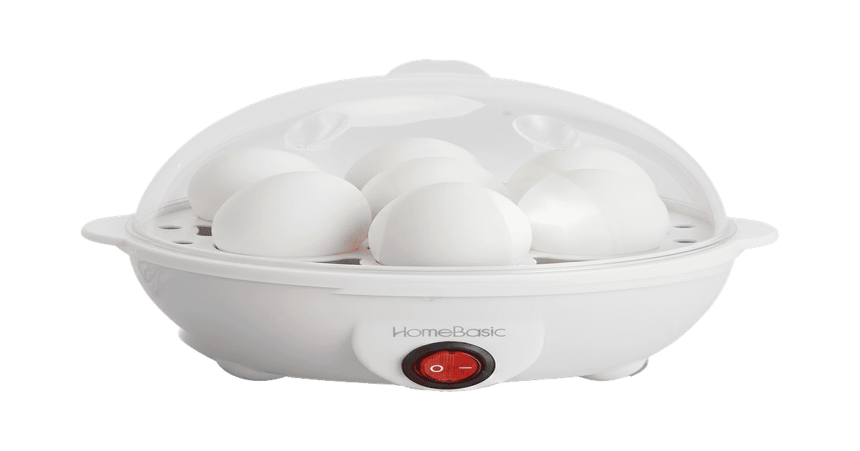

Additionally, modern egg boilers are designed with compact embedded control architectures that improve convenience and cooking consistency. The control system continuously monitors the temperature and operating conditions during the cooking process. Once the water inside the chamber evaporates completely, the temperature rises rapidly, and the controller automatically disconnects the power supply to the heating element. Simultaneously, indicators such as LEDs or buzzers notify the user that the cooking process is complete. Due to their automatic operation, low power consumption, fast heating capability, and enhanced safety features, egg boilers are widely used in homes, hostels, hotels, and smart kitchen environments.

WORKING PROCESS OF EGG BOILER

• Power ON / User Interaction
The process begins when the user switches ON the egg boiler and selects the required cooking mode such as soft boil, medium boil, or hard boil using the control switch or button panel.

• Water Filling and Egg Placement
The user adds the required quantity of water into the heating chamber and places the eggs on the egg tray inside the boiler.

• Input Setting
The user sets the timer or cooking preference according to the desired level of egg boiling.

• Water Level Detection
The system checks whether sufficient water is available in the chamber before starting the heating process.

• Controller Processing
The microcontroller or control circuit processes user inputs and sensor feedback to determine the required heating operation.

• Heating Element Activation
The controller supplies power to the electric heating element located beneath the water chamber.

• Steam Generation
The heating element heats the water, producing steam inside the chamber to cook the eggs uniformly.

• Temperature Monitoring
Temperature sensors continuously monitor the heating temperature and send feedback signals to the controller.

• Cooking Process
The generated steam transfers heat to the eggs, gradually cooking them according to the selected mode.

• Water Evaporation Detection
Once the water completely evaporates, the temperature rises rapidly, indicating the completion of the cooking process.

• Automatic Control Action
The controller automatically switches OFF the heating element to prevent overheating and unnecessary power consumption.

• User Notification
LED indicators or a buzzer alert the user that the eggs are fully cooked and the process is complete.

BLOCK DIAGRAM

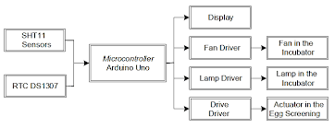

Block Diagram Explanation

• Input Unit: Used for setting cooking mode, timer, and boiling preferences such as soft, medium, or hard boiling.
• Controller Unit: The microcontroller controls the complete operation of the egg boiler by processing user inputs and sensor feedback.
• Power Supply Unit: Converts AC mains supply into regulated electrical power required for the controller and heating system.
• Heating Element: Converts electrical energy into heat for heating the water inside the chamber.

SPECIFICATIONS OF EGG BOILER

• Input Supply Voltage: 220V – 240V AC, 50 Hz
• Power Rating: 250 W – 500 W
• Heating Method: Electric Heating and Steam Generation
• Control Type: Push Button Control / Automatic Control System
• Display Type: LED Indicator / Power Indicator
• Temperature Range: Approximately 70°C – 100°C
• Cooking Modes: Soft Boil, Medium Boil, Hard Boil, Steam Cooking
• Timer Range: 5 minutes – 30 minutes
• Cooking Capacity: 6 – 14 Eggs (depending on model)
• Efficiency: Around 80% – 90%
• Protection Features: Overheat Protection, Auto Shut-Off, Dry Heating Protection
• Water Level Detection: Automatic Water Monitoring System
• Heating Element Material: Stainless Steel / Nichrome Heating Plate
• Tray Material: Food-Grade Plastic / Stainless Steel
• Controller Used: Microcontroller-Based Control System
• Safety Features: Thermal Fuse, Automatic Cut-Off, Indicator Buzzer
• Body Material: Heat Resistant Plastic with Stainless Steel Components
• Weight: Approximately 0.5 kg – 2 kg
• Applications: Homes, Hostels, Hotels, Restaurants, Smart Kitchens, Cafeterias

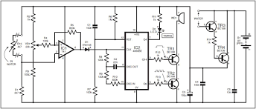

ADVANTAGES OF EGG BOILER

• Fast Cooking
Egg boilers cook eggs quickly using steam heating. The cooking time is much shorter compared to traditional boiling methods.

• High Energy Efficiency
Most of the electrical energy is efficiently converted into heat for steam generation. Very little energy is wasted.

• Automatic Operation
The appliance automatically controls the cooking process and shuts OFF after completion. Reduces the need for continuous monitoring.

• Safe Operation
No open flame is used during operation. Safety mechanisms reduce the risk of overheating and electrical hazards.

• Consistent Cooking Quality
The controller maintains proper heating conditions, ensuring uniformly cooked eggs every time.

• Easy to Use
Simple controls and automatic functions make the appliance user-friendly for all age groups.

• Automatic Shut-Off
The egg boiler automatically switches OFF when water evaporates completely. Prevents overcooking and saves energy.

• Compact Design
Occupies very little kitchen space. Portable and easy to carry or store.

• Easy to Clean
The simple structure and removable tray make cleaning and maintenance easy.

• Low Maintenance
Requires very little maintenance due to fewer moving parts and simple construction.

• Multi-Purpose Usage
Some egg boilers can also be used for steaming vegetables, momos, or other food item.

LIMITATIONS OF EGG BOILER

• Requires Electricity
Egg boiler cannot operate during power failure. Continuous electrical supply is necessary. Boiling process may stop suddenly during outages.

• Limited Capacity
Only a fixed number of eggs can be boiled at a time. Large quantity cooking is not possible in small models. Capacity depends on the size of the appliance.

• High Initial Cost
Egg boilers are costlier compared to traditional boiling methods. Advanced automatic models are more expensive. Maintenance cost may also increase.

• Electronic Circuit Failure
Failure of heating element or control circuits may affect operation. Repairs may require technical expertise. Damaged components may reduce efficiency and safety.

• Voltage Fluctuation Problems
Voltage variations can affect heating performance. May cause improper boiling or automatic shutdown. Stable voltage supply is required for proper operation.

• Overheating Risk
Improper water level or continuous operation may cause overheating. Excess heat may damage internal components. Careful usage is necessary for safety.

• Noise Generation
Some egg boilers may produce sound during heating or steaming. Continuous noise may cause discomfort during operation.

• Surface Damage
Plastic or metal body surface may get scratched if not handled carefully. Rough cleaning methods may reduce appearance and durability.

GPS IMAGE

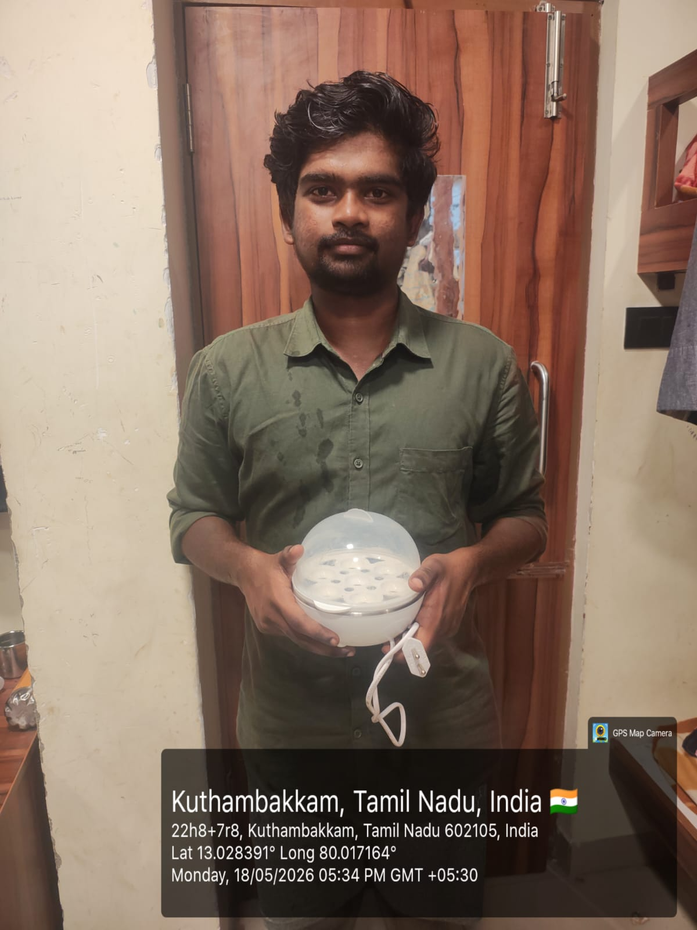

APPLICATIONS OF EGG BOILER

• Domestic Kitchens
Widely used in homes for quick and convenient egg boiling. Saves time and simplifies cooking process.

• Hotels and Restaurants
Used for preparing boiled eggs efficiently in large quantities. Helps maintain consistent cooking quality.

• Hostels and Apartments
Compact and portable design makes it suitable for small spaces. Easy to use for students and working people.

• Smart Kitchens
Integrated with automatic shut-off and timer controls. Suitable for modern smart kitchen setups.

• Cafeterias and Canteens
Used for fast preparation of eggs for breakfast and meal services. Improves serving efficiency.

• Catering Services
Portable egg boilers are useful for outdoor catering and events. Convenient for bulk egg preparation.

• Food Processing Industry
Used in commercial food preparation applications. Supports hygienic and uniform cooking.

• Energy Efficient Cooking Systems
Consumes less power compared to traditional boiling methods. Used where energy saving and safety are important.

CONTROL SYSTEM FEATURES OF EGG BOILER

• Automatic Temperature Control
Temperature sensors help maintain proper heating during boiling. Ensures uniform cooking of eggs.

• Closed Loop Operation
The controller continuously monitors the heating process. Necessary adjustments are made automatically for proper boiling.

• Automatic Protection System
Protects against overheating and dry heating conditions. Automatically switches off when water level becomes low or boiling is completed.

• Timer and Auto Shut-Off
Supports automatic cooking and timer functions. Device turns off automatically after eggs are cooked.

CONCLUSION

The egg boiler is an advanced kitchen appliance that uses automatic heating and control techniques for efficient and safe egg cooking. It functions as a closed-loop control system with input processing, controller operation, temperature sensing, and automatic heating regulation.

The system provides several advantages such as quick cooking, energy efficiency, automatic operation, and improved safety compared to traditional boiling methods. Features like automatic shut-off, overheating protection, and sensor-based monitoring enhance reliability and user convenience.

Although egg boilers have certain limitations such as dependency on electricity and limited cooking capacity, their advantages make them highly suitable for homes, hostels, restaurants, and modern kitchens.

In conclusion, the egg boiler is an excellent example of a practical control system application that combines heating systems, sensors, electronics, and automation for efficient real-world operation.

